Clearance To Race Formalities & Forms

Guidelines for Inspections
Before you can have your Inspection done, you must:
- Be checked-in at the Race Office
- Picked up your racer packet
- Apply all signage to your vehicles and bikes

Inspection Time
- Friday 11th June 2020 from XXH00 to ZZH00

Racers do not need to be present, their race equipment does.

Self-Check
We recommend doing a self-inspection before proceeding to the Official inspection by Race Officials. All Inspection Forms are included herein – make extra copies and run through it yourself. This will greatly speed up the Official Inspection.

Inspections
At your Inspection, a Race Official will meet you at your Follow Car in the inspection parking lot. Your racer vehicle numbers must be attached to your Follow Car so the Race Official can find you. If all your paperwork, bicycles, clothing and Follow Car are properly outfitted this inspection should be finished quickly.

Paperwork
- Vehicle Inspection Form.
- Equipment Inspection Form.

Vehicle Inspection
Proper lights, sign placement and clear window visibility for the driver of the Follow Car. The second seat rear passenger windows must be clear on the right side for giving handoffs to racers. If you have an extended van, the remaining third and fourth seat rear windows may have signage on the windows.

Bike Inspection
Follow Bicycles Rules (Section 6) from the Dizzy Challenge 2020 Rules. Make sure reflective tape and proper lights are installed and working on yours bikes. Make sure you have spare batteries to last all the race. All spare wheels and spare bikes must be outfitted with the proper safety equipment. Bike number tags need to be affixed to the bikes and visible. We recommend attaching these tags to the seat post.

Signed Approval
A Race Official will sign all Vehicle and Equipment Inspection Forms. If there is a problem with any vehicle or equipment, the Race Official will not sign off on the paperwork until that problem is corrected. A new inspection will be scheduled with the officials.

Most Common Errors
Leading causes of delays in vehicle inspection:
- Follow Car windows blocked by too many signs. See diagrams in later in this packet for acceptable placement locations on the vehicle.
- Rear amber flashers must only be visible from the rear.
- Reflective tape and lights mounted on all bicycles. Spare wheels must also have reflective tape. Spare batteries and chargers must also be inspected.

Inspection lot location
Example :
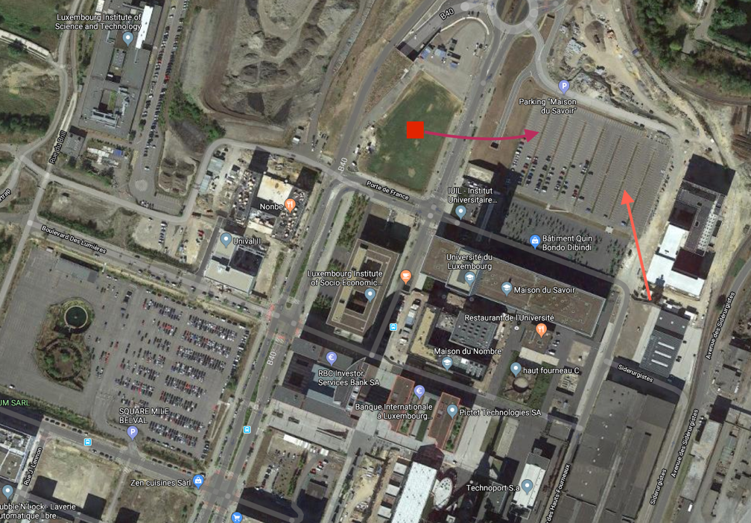

Arrival at Inspections
In order to ensure that the inspection process runs smoothly and efficiently, please use the following guidelines to prepare yourself and your vehicles for the inspection process. Upon arrival at the inspection lot, you will be directed by a race official to a specific location.

Please complete the following tasks prior to your inspection.

Bicycle
- Place all bicycles and spare wheels on the pavement next to your Follow Car
- Place all lights (front and rear) and batteries, which are not attached to a bicycle next to wheels (lights must be operational and will be checked by your Official)
- Place all numbered helmets next to wheels.

Vehicle
- Tape Dashboard Protocol to the dashboard of each vehicle (nëmmen wa mir data Dokument am Viraus ginn)
- Be prepared to start each vehicle and to turn on all lights, including hazard lights and amber/roof lights.
- Be prepared to show evidence of the Follow Car insurance and registration

Guidelines for Vehicle and Bicycle Setup
You will get the allotted sets of Follow Car signage at the registration. You will receive the following:
- 1 reflective “ATTENTION – COURSE CYCLISTE” sign (to be affixed on rear)
- 4 personalized Racer Number signs (one each to be affixed to front, rear and both sides)

NOTE: You must bring your own reflective triangles for the rear of your Follow Car. The personalized Racer Number signs will include the Racer’s name and Racer’s Number.
Four of these numbers will be displayed on each vehicle – one per side. Signs should be affixed as follows:
- One on each side of the vehicle at the door
- One on the upper left of the rear window
- One on the center of the front hood of the vehicle

This set of pages will demonstrate and describe where and how to place these signs.

Tips
- For any signs placed on vehicle paint, it is recommended that you first apply clear contact paper to your vehicle and then apply the vehicle sign. Contact paper is much easier to remove. Humidification of the surface with water containing some washing-up liquid is also a very efficient method. Take a credit card and rub the sign properly.
- The display of the ATTENTION COURSE CYCLSITE decal on the rear of the vehicle can either be one line or split in two or three lines

During the race, if signs start to peel off, cover the edges with clear contact paper.

Rear of the Vehicle
The rear of the vehicle is the most critical and most visible part of the vehicle. With many Racers using rear mounted bike racks, limitations on space are becoming critical.

The Racer Number sign must be mounted on the upper left of the rear window of the vehicle as illustrated in the photos that follow. If you do not have a rear bicycle rack, you can mount the ATTENTION COURSE CYCLISTE decal anywhere.

In general, you want to keep the rear window as clear as possible – both inside the vehicle and outside the vehicle.

Rear Bicycle Racks
If you have a rear bicycle rack, you must mount the ATTENTION COURSE CYCLISTE decal on the right side of the rear window in the stacked formation.

ATTENTION
COURSE
CYCLISTE

Your vehicle taillights must be visible. If you have disk wheels or deep profile rims and your taillights are not visible, you must remove those wheels or put on normal wheels when mounting your bike on the rear rack.

The Slow Moving Vehicle triangle must be visible – bikes and wheels cannot block the visibility of that triangle. The triangle must be mounted on the outside of the bicycles and rack.

Front Sign Locations

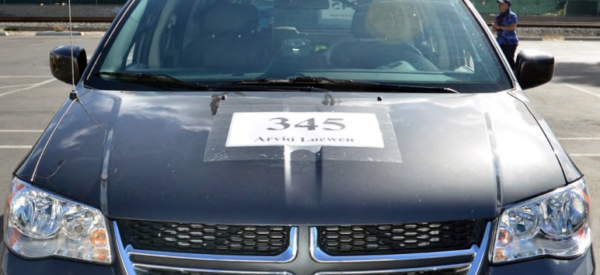

Racer Number sign on hood on vehicle

Side Sign Locations
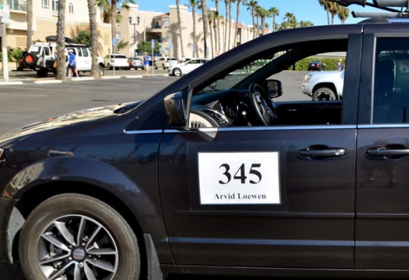

Racer Number sign on front doors (driver and passenger)

Rear Sign Location - No Bike Rack
Fotoen ascannen

Here are several possibilities:
- Racer Number sign on upper left rear window.
- “ATTENTION COURSE CYCLISTE” sign
- Slow Moving Vehicle triangle.
All are very visible and easy to see.

Rear Sign Location – With Bike Rack
Fotoen ascannen

In the picture below:
- The Slow Moving Vehicle triangle is clearly visible and on the outside of the bicycle
- The Racer # sign is in the upper left area of the rear window and clearly visible
- The “ATTENTION COURSE CYCLSITE” sign is in the upper right area of the right window, stacked and clearly visible

Window Visibility
Driver must have 360-degree visibility with windows or mirrors.

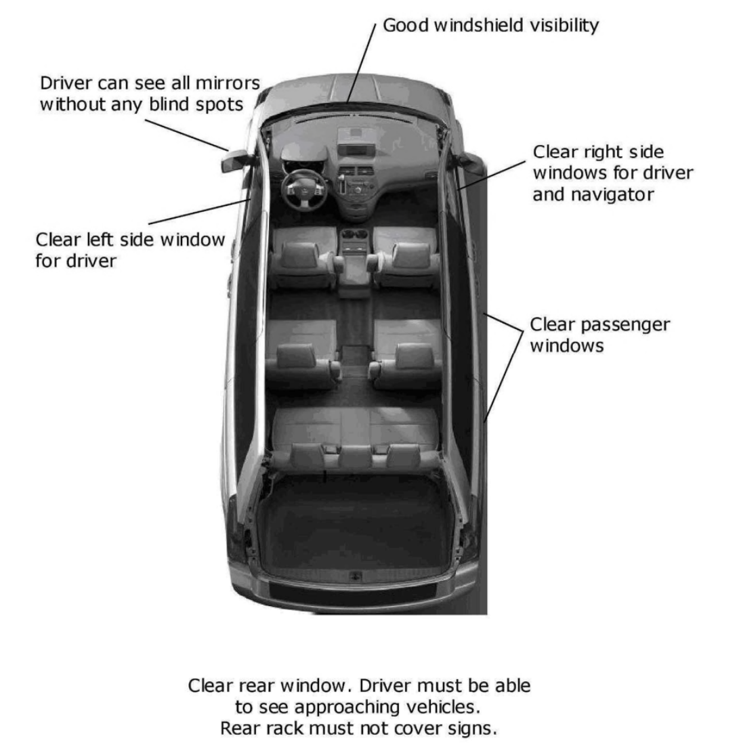

Bicycle Setup
Fotoen ascannen

Every bicycle must have reflective material applied to various parts of the bike for visibility. (See the Rule Book for specific locations and amount). Every bicycle must also have front and rear lights. We understand that cranks can be narrow. We want the reflective tape to be as wide as possible on those areas.

For wheels, the easiest place to put reflective material is on the rims. However, tape should not be applied to the braking surfaces.

HINT: Consider putting electrical tape or clear contact paper on the bicycle cranks and rims, and then applying reflective material to these materials. Electrical tape and clear contact paper are easier to remove than reflective tape. Reflective material must remain in place for the entire race.

Mandatory forms and agreements
These forms and agreements below will help your pre-race organization and the process of getting everything done at the start before the racers depart. The forms are broken down into sections with instructions for each.

At the Start
When you arrive at Esch/Alzette, check-in at the Dizzy Challenge 2020 Start Office
adresse à préciser

You must check-in and pick up your racer packet, which includes signage, route books, etc., before your inspection. Be sure to attach all racer numbers and signage to your Follow Car, bicycles and bike helmets before inspection.

Check-In and racer package pick-up starts Friday, 11th June 2020 at XXh00. It is recommended that the Crew Chief pick-up all materials.

All forms are included:
- Clearance to Race Form A
- Follow Car Insurance Agreement
- Driver’s License Agreement
- FC Inspection Form
- Equipment Inspection Form
- Waivers Form
- Dashboard Protocols

All forms are also available on the website under ……………….. You should make additional
copies of any forms as needed.

Bring your phones to the Race Office. We will call these numbers from the Race Office at the start to verify it works.

You must print the following pages and show the up when
- checking-in and picking up your racer packet,
- the Follow Car and the Equipment Inspection is performed.

Clearance To Race Form A

Instructions : Fill out the list below and provide a copy of a valid identification document (identity card or passport) of the Racer, the Crew Chief and each Crew Member.

Racer’s Name: __________________________________________________________
Birthdate : _________________ Identity card / passport number: _____________

Crew Chief’s Name: ______________________________________________________
Birthdate : _________________ Identity card / passport number: _____________

#1 Crew Member’s Name: _________________________________________________
Birthdate : _________________ Identity card / passport number: ______________

#2 Crew Member’s Name : ___________________________________________________
Birthdate : _________________ Identity card / passport number: ______________

#3 Crew Member’s Name : __________________________________________________
Birthdate : _________________ Identity card / passport number: _____________

#4 Crew Member’s Name : ________________________________________________
Birthdate : _________________ Identity card / passport number: _____________

#5 Crew Member’s Name : ____________________________________________________
Birthdate : _________________ Identity card / passport number: ______________

#6 Crew Member’s Name : ____________________________________________________
Birthdate : _________________ Identity card / passport number: _____________

Crew Chief Signature: _______________________________ Date: _______________

Follow Car Insurance Agreement

Instructions
- Fill out and sign the Follow Car Insurance Agreement Form
- Insert copy of proof of insurance (or rental agreement)

Proof of Insurance can be in several forms:
- A personal insurance policy for a personal (non-rental) vehicle
- A rental agreement with verification of acceptance of Insurance Coverage provided by the rental agency

In consideration of the acceptance of my participation in the Dizzy Challenge 2020, I hereby affirm that the motorized vehicle listed below to be used as Follow Car in the Race is covered with at least the minimum insurance requirement per the state of vehicle registration. A copy of the proof of vehicle insurance (or rental agreement) is included.

Vehicle Make and Model: _________________________________________

State and License : _______________________________________________

Race Official Signature:_____________________________ Date: _______________

Crew Chief Signature: _______________________________ Date: _______________

Driver’s License Agreement

Instructions
- Fill out and sign the Driver’s License Agreement Form
- Insert copy of driver’s license for every Crew Member who will be driving during the Race.

In consideration of the acceptance of my participation in the Race Dizzy’s Challenge 2020, I affirm that any Crew Member who drives the Follow Car possesses a valid driver’s license for operating this motor vehicle on the roads in Luxembourg and is authorized to drive that vehicle. For each driver a copy of their driver’s license is included.

Number of Drivers: __________________

 | Name & Surname | License’s n° | Issuing country
Driver #1

Driver #2

Driver #3

Driver #4

Driver #5

Driver #6

Race Official Signature:_____________________________ Date: _______________

Crew Chief Signature: _______________________________ Date: _______________

Follow Car Inspection Form

License Number and State: __________________________

Make/Model/Color of Vehicle: ____________________________________

Control | OK / NOT OK | Initial Race Official
Flashing Amber Roof Lights
Head Lights/High Beams
Brake Lights
Tail Lights
Turn Signals
Reverse Lights
Factory Emergency Flashers
LED Light Bars
Official Racer Number (x4)
Attention Course Cycliste
Dashboard Protocol
Slow-Moving Triangle
360° Visibility
Passenger Windows clear

Vehicle night-time head lights, emergency flashers, and flashing amber roof lights MUST ALL BE VISIBLE DAY AND NIGHT. Equipment used in any previous race must meet all current Rules and pass all current inspections. Judgment of the Race Official is final. If your equipment is deficient, a second inspection will then be required prior to the race start to clear the deficiency. A Race Official’s signature indicates a successful inspection.

Notes:
- Inspections are not intended to certify the fitness or roadworthiness of the vehicle. The inspection is done only to determine whether the Racer and Crew possess the appropriate safety equipment for the Race and meet all Rules.
- During inspection we can only assess if amber lights work or not, we cannot assess brightness or visibility. Be sure to check visibility of your lights at night before coming to the Race. During the Race, if a Race Official assesses your lights to be too bright or too dim, a Race Official will request modification to ensure visibility.

Race Official Signature:_____________________________ Date: _______________

Crew Chief Signature: _______________________________ Date: _______________

Equipment Inspection Form
Bicycle/Lights/Wheels/Helmet

Total number of bicycles (all bicycles are reported on this form): __________

Brands of bicycles inspected: ____________________________

Total number of spare wheels (including spare wheels) : ____________

Control | OK / NOT OK | Initial Race Official
Front headlight
& batteries/charger
Red rear taillight
& /batteries/charger
Official bicycle number tag
visible from the seated racer’s left side
Reflective Tape on all wheels
min. 4 pieces, each piece at least 1 cm wide by 3 cm long, on each side of every wheel, including spare wheels. Eight pieces total per wheel. Reflective writing does not count.
Reflective Tape on Cranks
One piece of reflective tape, at least 1 cm wide and 7,5 cm long, wrapped completely around each crank halfway between the bottom bracket axle and the pedal axle so reflective tape is visible from any direction.
Helmet in good condition (& spare helmet)
Official helmet number tag
visible from the seated racer’s left side

Front headlight, red rear taillight, reflective tape on wheels and cranks, and helmet MUST BE VISIBLE AT ALL HOURS, DAY AND NIGHT, while the active racer is on the road.

Equipment used in any previous event must meet all current Race Rules and pass all current
inspection standards.

Judgment of the Race Official is final. If your equipment is deficient, a second inspection will then be required prior to the race start to clear the deficiency. An Official’s signature indicates a successful inspection.

Race Official Signature:_____________________________ Date: _______________

Crew Chief Signature: _______________________________ Date: _______________

RELEASE AND WAIVER OF LIABILITY, ASSUMPTION OF RISK, AND INDEMNITY AGREEMENT ("AGREEMENT")

Instructions:
- You have to remit a originally signed form for the Racer and each Crew Member
- Make ass many copies as needed to be signed

In consideration of participating in the DIZZY CHALLENGE, I represent that I understand the nature of this activity and that I am qualified, in good health, and in proper physical condition to participate in such activity. I acknowledge that if I believe event conditions are unsafe, I will immediately discontinue participation in the activity.

I fully understand that this activity involves risks of serious bodily injury, including permanent disability, paralysis and death, which may be caused by my own actions, or inactions, those of others participating in the event, the conditions in which the event takes place, or the negligence of the "releasees" named below; and that there may be other risks either not known to me or not readily foreseeable at this time; and I fully accept and assume all such risks and all responsibility for losses, costs, and damages I incur as a result of my participation in the activity.

I hereby release, discharge, and covenant not to sue Cycling for Health asbl and their respective administrators, directors, agents, officers, volunteers and employees, other participants, any sponsors, advertisers, and, if applicable, owners and lessors of premises on which the Activity takes place, including without limitation the Luxembourg State, cities, towns, villages, municipalities and unincorporated places and the like as well as employees and agents of such places that a race participant passes through during the DIZZY CHALLENGE, Law Enforcement Agencies and other Public Entities providing support for the DIZZY CHALLENGE, (each considered one of the "RELEASEES" herein) from all liability, claims, demands, losses or damages on my account caused or alleged to be caused in whole or in part by the negligence of the RELEASEES or otherwise, including negligent rescue operations; and I further agree that if, despite this release, waiver of liability, and assumption of risk I, or anyone on my behalf, makes a claim against any of the releasees, I will indemnify, save, and hold harmless each of the RELEASEES from any loss, liability, damage, or cost which any may incur as the result of such claim.

I have read this RELEASE AND WAIVER OF LIABILITY, ASSUMPTION OF RISK, AND INDEMNITY AGREEMENT, understand that I have given up substantial rights by signing it and have signed it freely and without any inducement or assurance of any nature and intend it be a complete and unconditional release of all liability to the greatest extend allowed by law and agree that if any portion of this agreement is held to be invalid the balance, notwithstanding, shall continue in full force and effect.

Date: ________________

Printed name of participant : ______________________________________________

Signature of participant : _________________________________________________

DASHBOARD PROTOCOL
TO BE FIXED IN THE FOLLOW CAR

- Display on the dash of all support vehicles.
- Turn on headlights at all times while driving.
- Drive at highway speeds when not following your Racer.
- No slowing to talk to the Racer during leapfrog support.
- No vehicle handoff during leapfrog.
- When stopping, keep the vehicle completely off the roadway (1,5 meter to the right of the driving lane).
- When following your Racer stay as far to the right of the traffic lane or on the paved shoulder as possible.
- On narrow twisting roads, allow following traffic to pass. You must pull off the roadway and stop at a safe pullout area. At night the rider must stop also.
- Dim your head lights for approaching or passing traffic.
- Your hazard lights and amber roof lights must be turned on and your slow moving triangle and Caution Bicycles Ahead sign must always be visible when following your Racer.
- Courtesy is Faster Than Controversy. Wave to passing motorists. Yield to fast wide trucks. A safe race is a fast race.

ech giff proposéieren dass den Organisator dest Dokument als DinA 5 plastifizéiert an bei der Insprectioun oder bei der Aschreiwung un all Ekipp aushändigt

Instructions for Race Officials

You must complete the list below. For each task, it must be signed off by a Race Official indicating successful completion. Once all are complete, you must turn this form back with all mentioned forms et agreements to Race Office to receive the final clearance to race form the Race Director.

Task | OK | Race Official Signature
Registration

Racer Packet picked up

Clearance to Race Form A

Follow Car Insurance Agreement

Driver’s Licenses Agreement

Follow Car and Equipment Inspection

Primary Mobile Number:

Secondary Mobile Number:

Releasees and waivers

Dashboard

Official Signature :____________________________ Date:__________

Crew Chief Signature :____________________________ Date: __________

Final clearance to race | Signature Race Director | Signature

